**Unit: Manual Motor Controls Quiz: 4**

**Basic Motor Controls and Single-Phase Motors CLO#: 1**

Name ______________________________ Date ______________

**Instructions**

Identify each component of the AC single-phase motor.

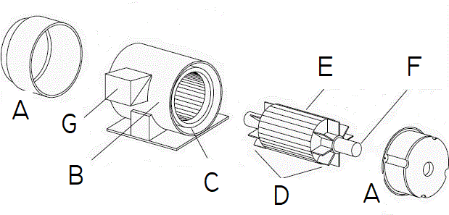

1. __________________
2. __________________
3. __________________
4. __________________
5. __________________
6. __________________
7. __________________
8. What is the term used in the field for the Single-Phase AC induction motor that we are using in class? _______________________
9. What is the field term for the terminal box on the side of a motor? ___________

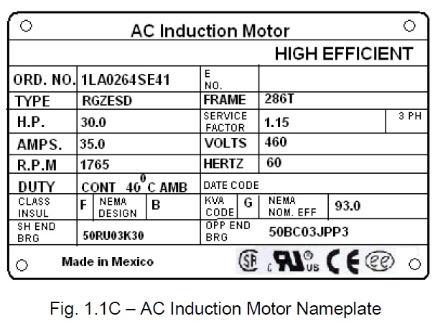

1. What is the horsepower for this motor? __________
2. How many watts should this motor dissipate? ______________
3. What nominal voltage level would you use to connect to this motor? ___________
4. What is the acceptable range of voltage input to this motor? _______ to _______
5. What is the RPM for this motor? ____________
6. If the motor is running at the minimum voltage that you calculated above, it would spin at a slower RPM?
   1. True
   2. False
7. What is a safe and acceptable way to vary the speed of this motor? ____________

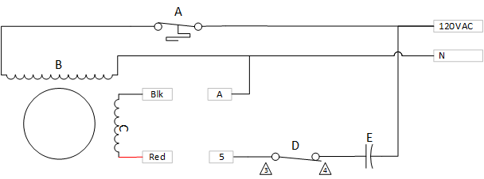

1. List the components in the above single-phase motor schematic and explain their purpose.
   1. ___________________________________________________________

___________________________________________________________

* 1. ___________________________________________________________

___________________________________________________________

* 1. ___________________________________________________________

___________________________________________________________

* 1. ___________________________________________________________

___________________________________________________________

* 1. ___________________________________________________________

___________________________________________________________

1. If the motor is running CCW with Blk wired to A and Red wired to 5, how should the motor be re-wired to obtain a CW rotation?
2. Explain why re-wiring this winding causes the motor to rotate in the opposite direction?
3. This motor can change its rotation while running.
   1. True
   2. False
4. How does having a capacitor in the circuit cause the motor to rotate in one direction or the other?
5. An AC induction motor has a permanent magnet that creates the magnetic field.
   1. True
   2. False
6. Mark up the drawing of a stop/start circuit below to correct any issues/omissions. (25 Points)

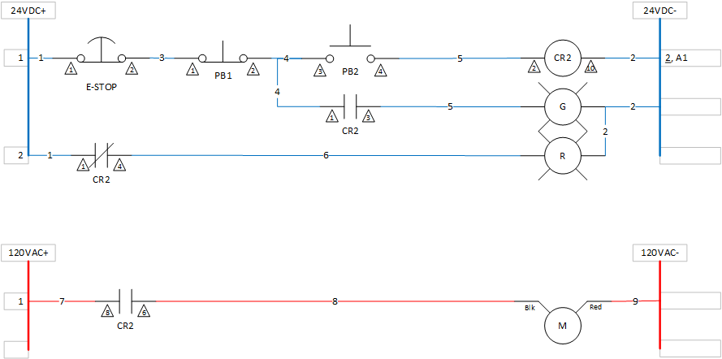

For the below drawing, calculate how many states it shall have, build a truth table and compose a formula.

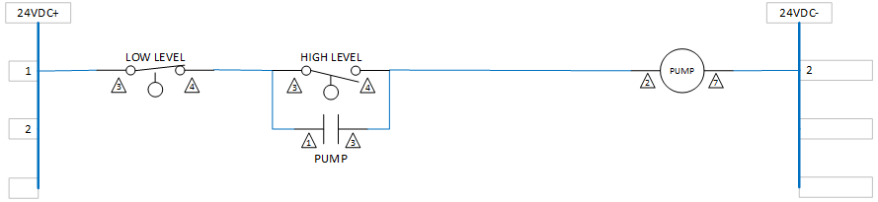

|  |  |  |
| --- | --- | --- |
| Low Level | High Level | Pump |
|  |  |  |
|  |  |  |
|  |  |  |
|  |  |  |
|  |  |  |